INFOSYS SPRINGBOARD VIRTUAL INTERNSHIP
MODULE-1
NAME: N.Rachana
PROJECT NAME: HotelRevAI AI Driven Revenue Analysis for Hotels_Batch -13
About the Project:
HotelRev Analyze is a data analytics project developed to evaluate and monitor hotel performance using booking and revenue data. The project focuses on analyzing important hotel performance metrics such as Occupancy Rate, Average Daily Rate (ADR), and Revenue Per Available Room (RevPAR) to understand how efficiently hotel rooms are being utilized and how much revenue they generate.
The project involves preparing booking data in Microsoft Excel, transforming it using Power Query, and creating calculated metrics and dashboards in Power BI. Through this process, raw booking data is converted into meaningful insights that help identify trends in hotel demand, pricing strategies, and seasonal performance.
The final output of the project is an interactive Power BI dashboard that visually represents hotel revenue performance through charts, KPI cards, and tables. These insights help hotel management understand occupancy trends, compare revenue across time periods, and make data-driven decisions to improve profitability.
MODULE 1:INTRODUCTION AND DATA PREPARATION
Objective:-
The objective of Module 1 is to generate a realistic hotel booking dataset using Python. Synthetic data is created for customers, hotel branches, room types, and bookings to simulate real hotel operations. The generated data is exported into CSV files. These datasets serve as the foundation for further data transformation and analysis in Power BI.
Step-1: GENERATE BASIC DATASETS
The datasets were generated using a Python script that simulates hotel booking operations. Random data was created for customers, hotel branches, room types, and booking transactions using Python libraries such as csv, random, and datetime. The generated data was then exported as CSV files to be used for further analysis in Power BI.

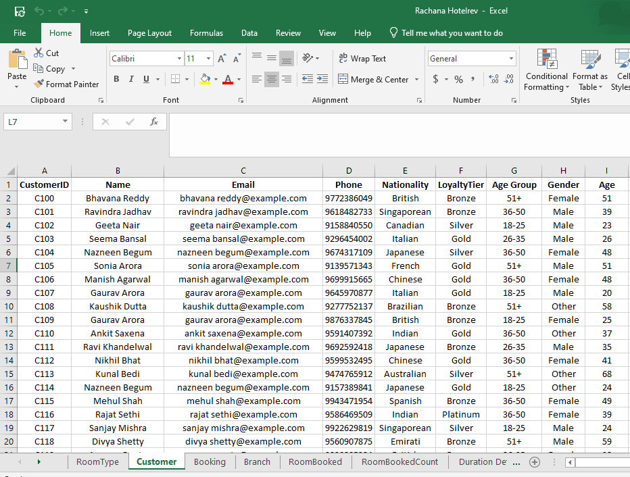

Customer.csv:
- CustomerID
- Name
- Email
- Phone
- Nationality
- Loyality tier
- Gender
- Age
Booking.csv:
- BookingID
- CustomerID
- RoomTypeID
- BranchID
- CheckInDate
- CheckOutDate
- Duration
- Revenue
- BookingStatus
- CancellationReason
- LeadTime
- PaymentMethod
- DiscountApplied
- BookingChannel
Branch.csv:
- BranchID
- BranchName
- City
- Phone
- ManagerName
- StarRating
- HasPool
- HasConferenceRoom
RoomType.csv:
- RoomTypeID
- RoomType
- Price
- MaxOccupancy
- Amenities
- IsAC
- IsSeaFacing
Step-2: Creating Additional coulmns required for Analysis.
In Booking.csv we have added staytype, RoomNightSold So that we can use it for accurate analysis.
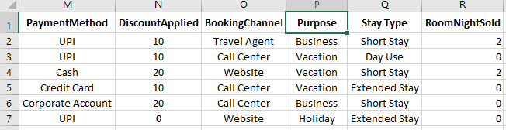
StayType Formula:
=IF(H2=1,"Day Use",
IF(H2<=2,"Short Stay",
IF(H2<=5,"Extended Stay",
"Long Stay")))
RoomNightSold Formula:
=SUMIFS(H2, J2, "Checked-In")
Step-3: Importing the data into PowerBI
The prepared dataset files were imported into Power BI using the Get Data option. This step allows the data to be loaded into Power BI for further transformation, modeling, and visualization.
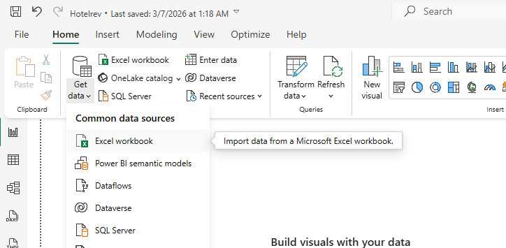
Select necessary tables and then click load
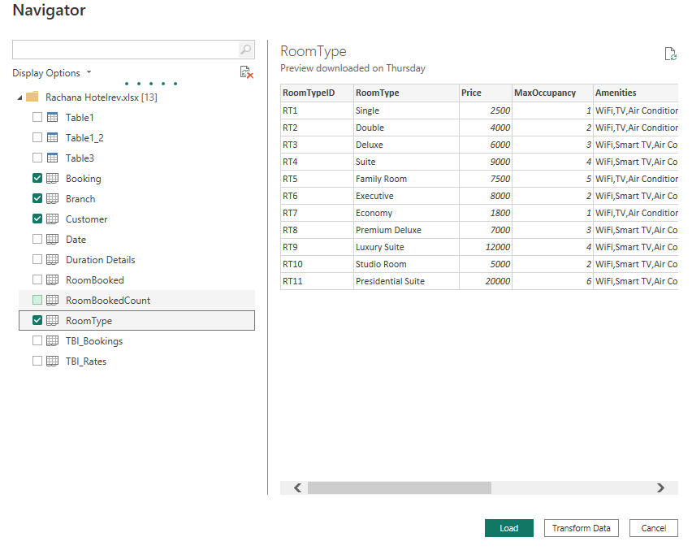
Step-3: Create STAR schema in PowerBI
After importing the datasets, a Star Schema data model was created in Power BI by connecting the fact table (Booking) with related dimension tables such as Customer, Branch, and RoomType. This structure helps organize the data efficiently and improves performance for analysis and reporting.
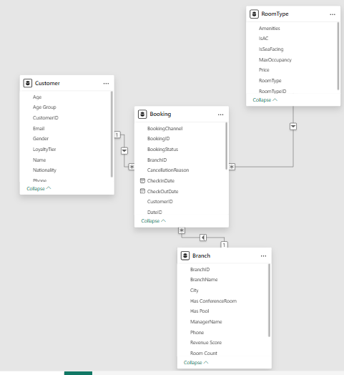
Relationships between the tables as given in the following figure:
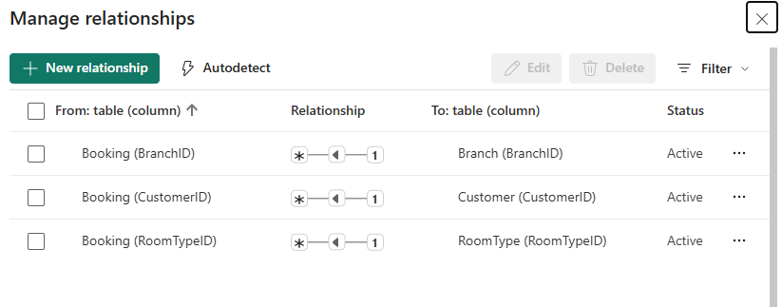
Conclusion:
In this module, the required datasets for the hotel revenue analysis project were successfully generated using Python. Additional columns needed for analysis were created using Excel formulas, and the prepared datasets were imported into Power BI. Finally, a star schema data model was created to organize the data efficiently for further transformation, analysis, and visualization.

